Industrial Training (Android Bootcamp)

Project Name: Guess Game

Group Members

|  |  |  |
| --- | --- | --- |
| S.no | Name | Roll No |
|  | Samrat Basu | 9 |
| 2. | Sunsnigdha Bharati | 10 |
| 3. | Sibasis Bhattacharjee | 11 |
| 4. | Anirban Bhattacharya | 12 |

Index

|  |  |  |
| --- | --- | --- |
| S.no | Title | Page no. |
| 1. | About the Project | 3 |
| 2. | Technologies Involved | 4 |
| 3. | Methodologies Involved | 4 |
| 4. | System Design | 5 |
| 5. | Database Schema | 8 |
| 6. | Screen-shot of the Running Project | 9 |
| 7. | Future Scope | 13 |

About the Project (Scope)

This project deals with an android-based application whose focus is to act as a guessing game. The app provides the users to select between two modes namely animals and flowers. Each of the modes presents the user with 25 images of animals/flowers each appearing in succession. Each image comes with four options out of which one is the correct name for the given flower or animal. Once a user presses an option he/she can move on to the next picture. The project aims to alleviate boredom in users interested in a simple gaming structure and enjoy such genre of games.

Technologies Involved

The following technologies has been used to build the project:

* IDE Used: Android Studio 3.4.0
* Testing App: Android SDK Emulator
* Database Used: Real Database
* Programming Language: JAVA

Methodologies Involved:

To build this project we followed the basic Software Development Life-Cycle model i.e. the Waterfall Model. Following are the steps followed:

* Feasibility Study: The first and foremost task was to find out if the project was feasible. The project was handed to us by our mentors and after going through the outcomes and aims of the project with them it was found that the project could be implemented.
* Requirement Gathering/Analysis: This phase was also done by the help of our mentors. Strict guidelines were provided dictating the bare minimum outcome that the project should achieve. Following those guidelines the following were the requirements:  
    
  1. The app should contain a login form where in the user can sign in using a username.  
    
  2. There should be two modes to select from namely flower and animals.  
    
  3. Each mode should have at least 25 images.  
    
  4. There should be a timer present which will determine the maximum time a user will get to guess one image.  
    
  5. There will also be concepts of lives. A user will lose if he/she gives multiple wrong answers which cross a certain limit.  
    
  6. Finally the user can view there score and see where they stand among various other users.  
    
  7. There should be at least 10 results on the scoreboard.  
    
  In lieu of the requirements and the skills of the members the project was decided to be built on the Android Studio IDE using JAVA as the programming language and Realm as the database.
* Design: The basic layout and UI was designed before moving onto implementation.
* Coding/Implementation: The back end part of the project was written on JAVA.
* Testing: Various tests were done using the emulator. The app was also tested on other mobile devices during various stages.
* Deployment: The app is finally ready to be submitted as a completed project.
* Maintenance: N/A (unless required by the mentors).

System Design

The Guess Game has five main activities working in it’s back end. Following are the descriptions and working of each of the activities.

* MainActivity: This is the root activity meaning when the user clicks on the app the layout of the MainActivity comes into display. It features a textbox for entering the username and a play button to start playing the game. It also has the leader board button to check the rankings of various users. On clicking the play button upon entering a username the user is taken to the next activity which is the GameActivity.
* GameActivity: The GameActivity layout provides the user with two choices. They an choose between two modes: Animals or Flowers. Depending on what they choose they will be taken to either of the following two activities:  
    
  1. AnimalQuizActivity: If the user chooses the animal mode then they will be brought to this activity. The layout of this activity mainly consists of an image featuring an animal. Below the image are four options out of which only one is correct. The user can click on next to move on to the next animal. The user can see a timer of 8s running in the upper left corner. Once the timer runs out the user cannot guess the given animal anymore and will be automatically directed to the next animal. This procedure will continue until all the images are exhausted or the user loses their lives after attempting multiple wrong answers.  
    
  2. FlowerQuizActivity: If the user chooses the flower mode then they will be brought to this activity. The layout of this activity mainly consists of an image featuring a flower. Below the image are four options out of which only one is correct. The user can click on next to move on to the next flower. The user can see a timer of 8s running in the upper left corner. Once the timer runs out the user cannot guess the given animal anymore and will be automatically directed to the next flower. This procedure will continue until all the images are exhausted or the user loses their lives after attempting multiple wrong answers.
* DisplayActivity: If the user chooses to click on the leader board button on the MainActivity they will be taken to a new view which layout which will display the ranks of various players who have used the game.

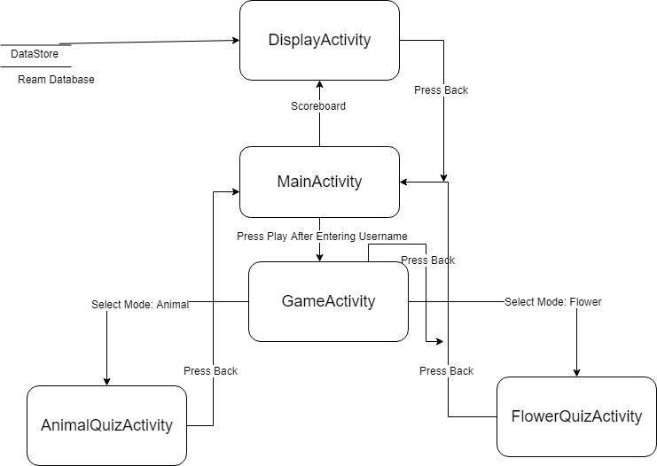

Database Schema

The following POJO class’s member variables are the fields of the Realm database and the entire POJO class represents the database schema.

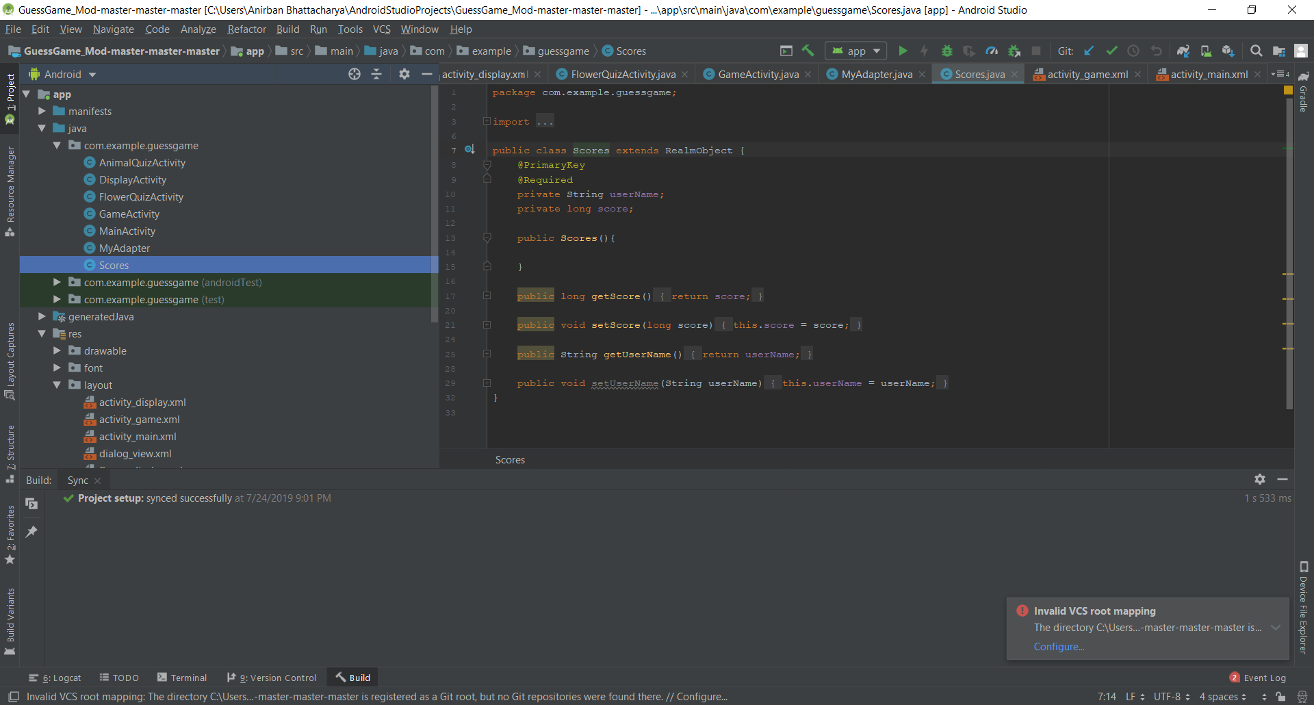

The fields of the database are:

* Username: Every user will provide their unique username
* Score: The score will be calculated for each user based on the number of correct choices they make.

Screen-shots of the Running Project

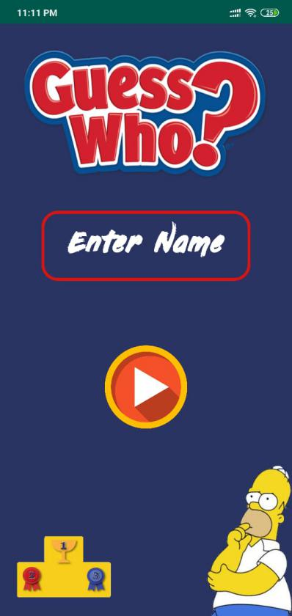 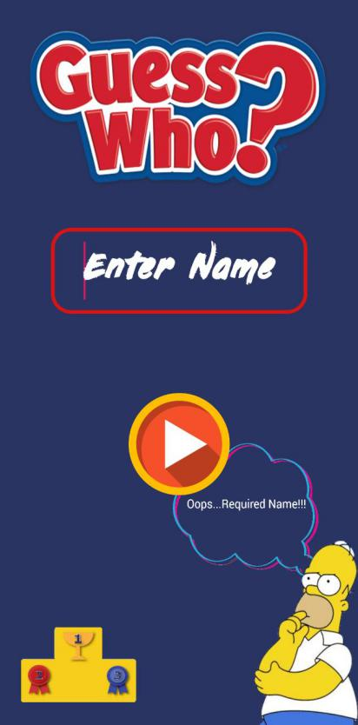

Fig. 1 Front Screen Fig. 2 If play button is clicked without entering username

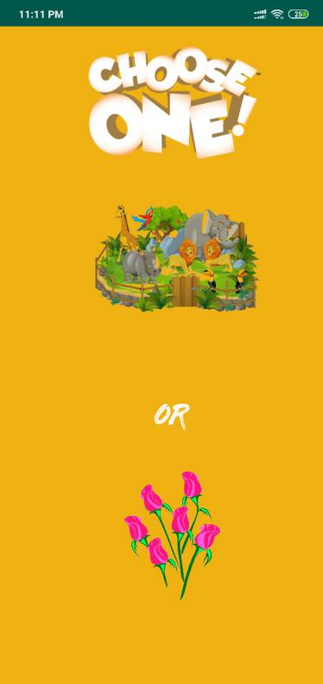

Fig.3 Select Mode

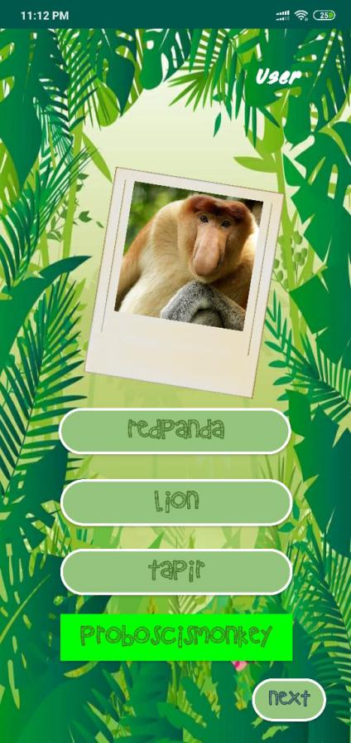 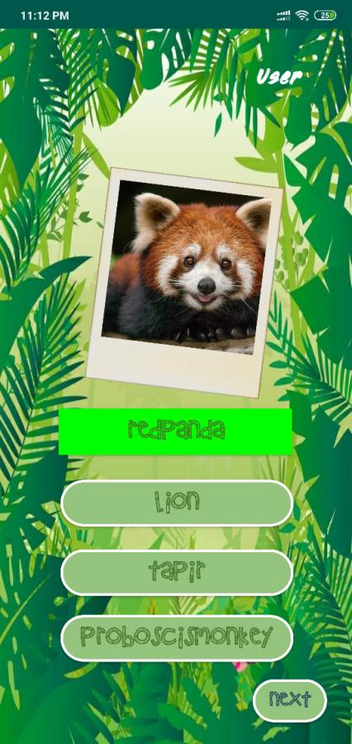

Fig. 4 Animal Quiz Fig. 5 Animal Quiz

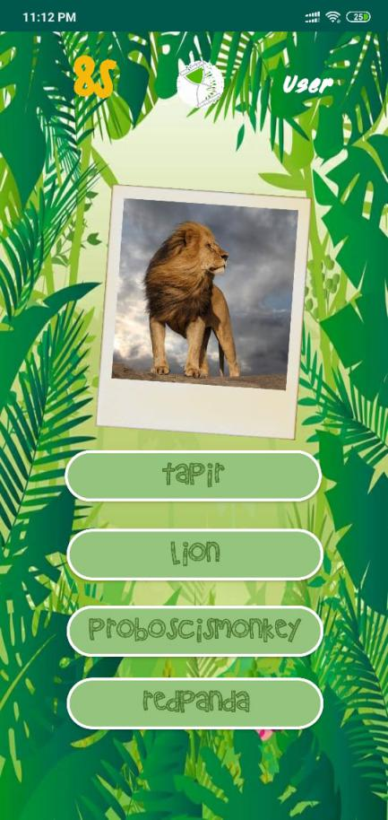 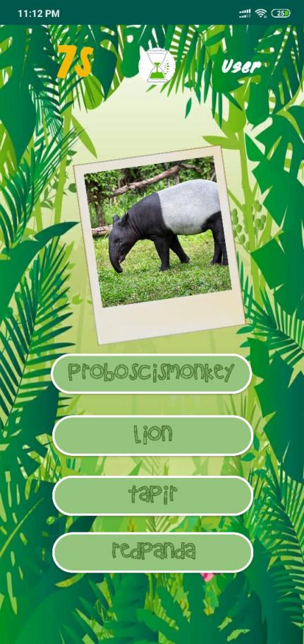

Fig. 6 Animal Quiz Fig. 7 Animal Quiz

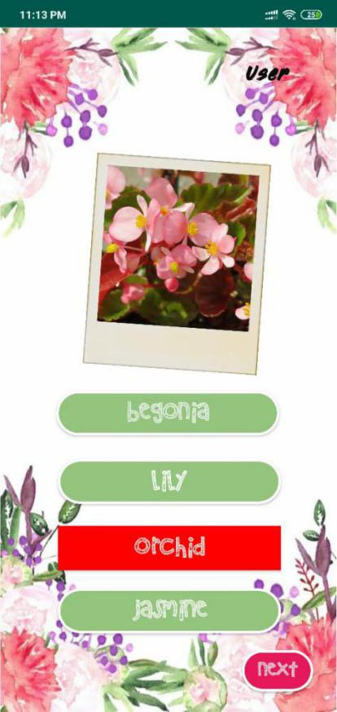 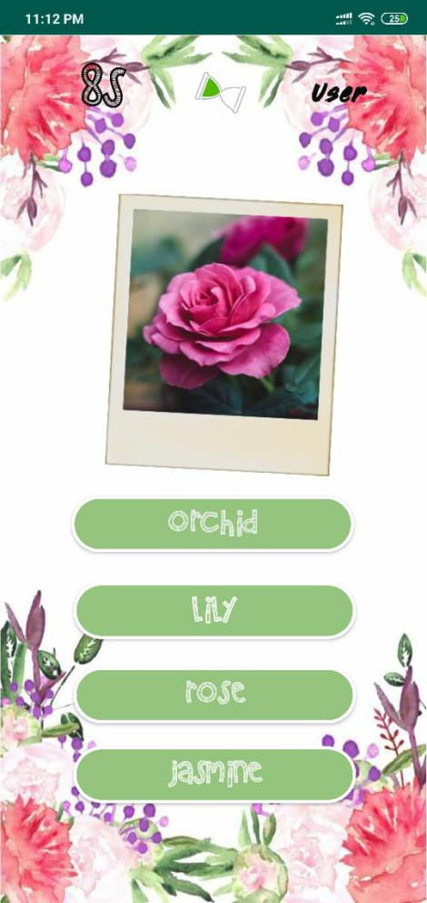

Fig. 8 Flower Quiz Fig. 9 Flower Quiz

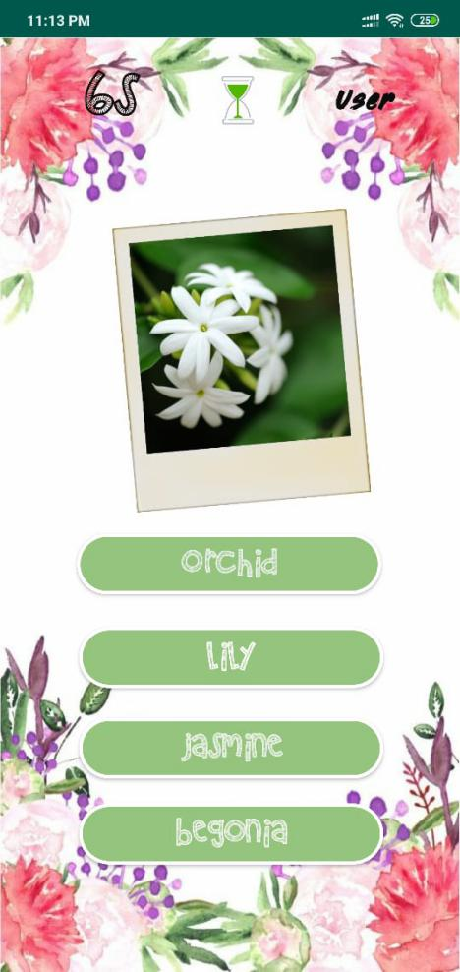

Fig. 10 Flower Quiz

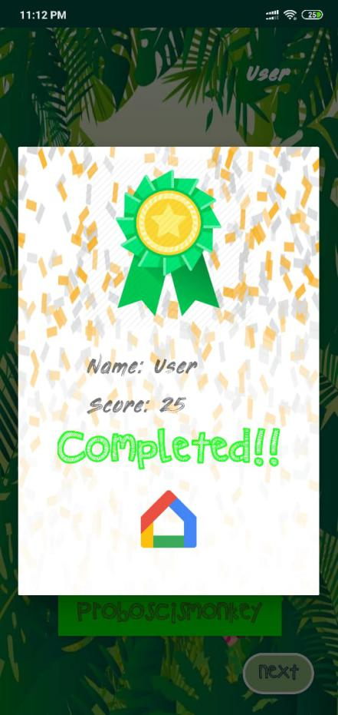 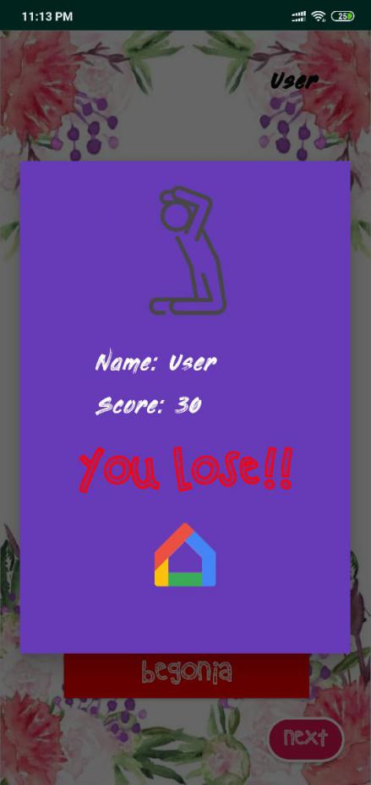

Fig. 11 Displaying Result (Success) Fig. 12 Displaying Result (Unsuccessful)

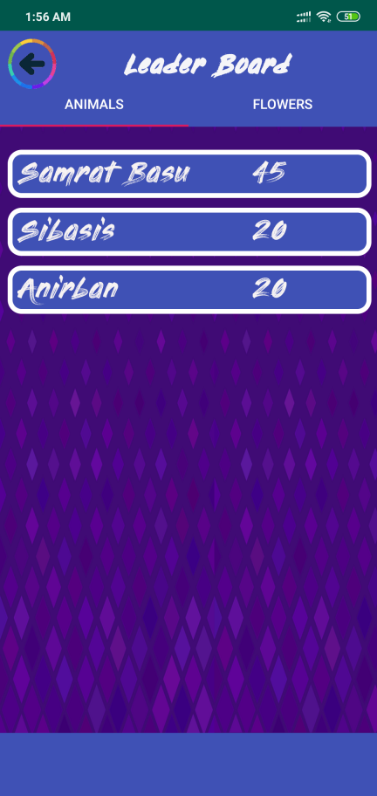 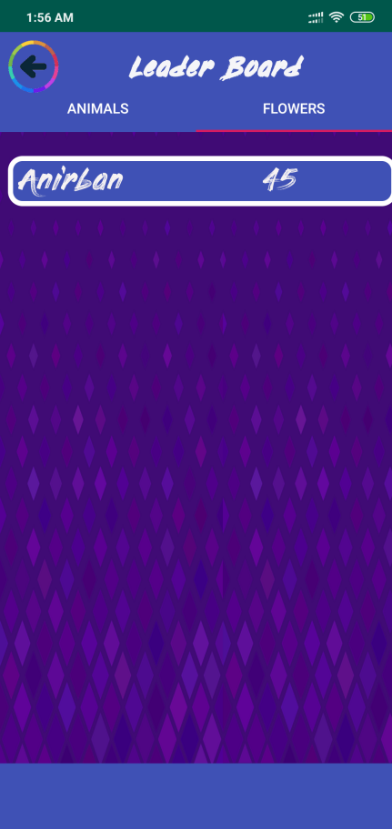

Fig 13. Leader board(Animal) Fig. 14 Leader board(Flower)

Future Scope:

The project can be improved in certain ways. If the user gets an answer wrong then hint can be given which can help the user guess the answer. Also, for each user the correct answers given can be stored in the database. The user can then click on any of these to get a detailed description of the object viz. Animal/flower. To make it harder for the user to guess the object the images can be blurred just a little.